Pitch:

Hook:

* Waste valorisation (numbers).
* Smart cities & urbanisation & huge drive to build new houses in the UK (help to buy scheme and local councils).
* Sustainability. Recyclability (lack in cement and gypsum boards 🡪 mainly from construction sites) + cambond (biodegradability). Carbon footprint numbers (-40%).

Hit:

* Low temperature firing process. Removes the need for toxic coatings (No need for coatings (curing)) compared to processed wood panels.
* Low cost (very competitive in price) 3.50 for a 12 mm board compared (class B average for competitors of the same thickness).
* 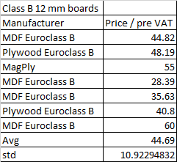
* Rigid boards (innovative bioresin improves the binding strength of the boards).
* Mention scalability 🡪 mention impressive partnerships (SAPPI) & manufacturing facilities (capacity)?

Echo:

* Journey (circular economy).